ML525 MINI TRACK LOADER SPECIFICATIONS
DIMENSIONS
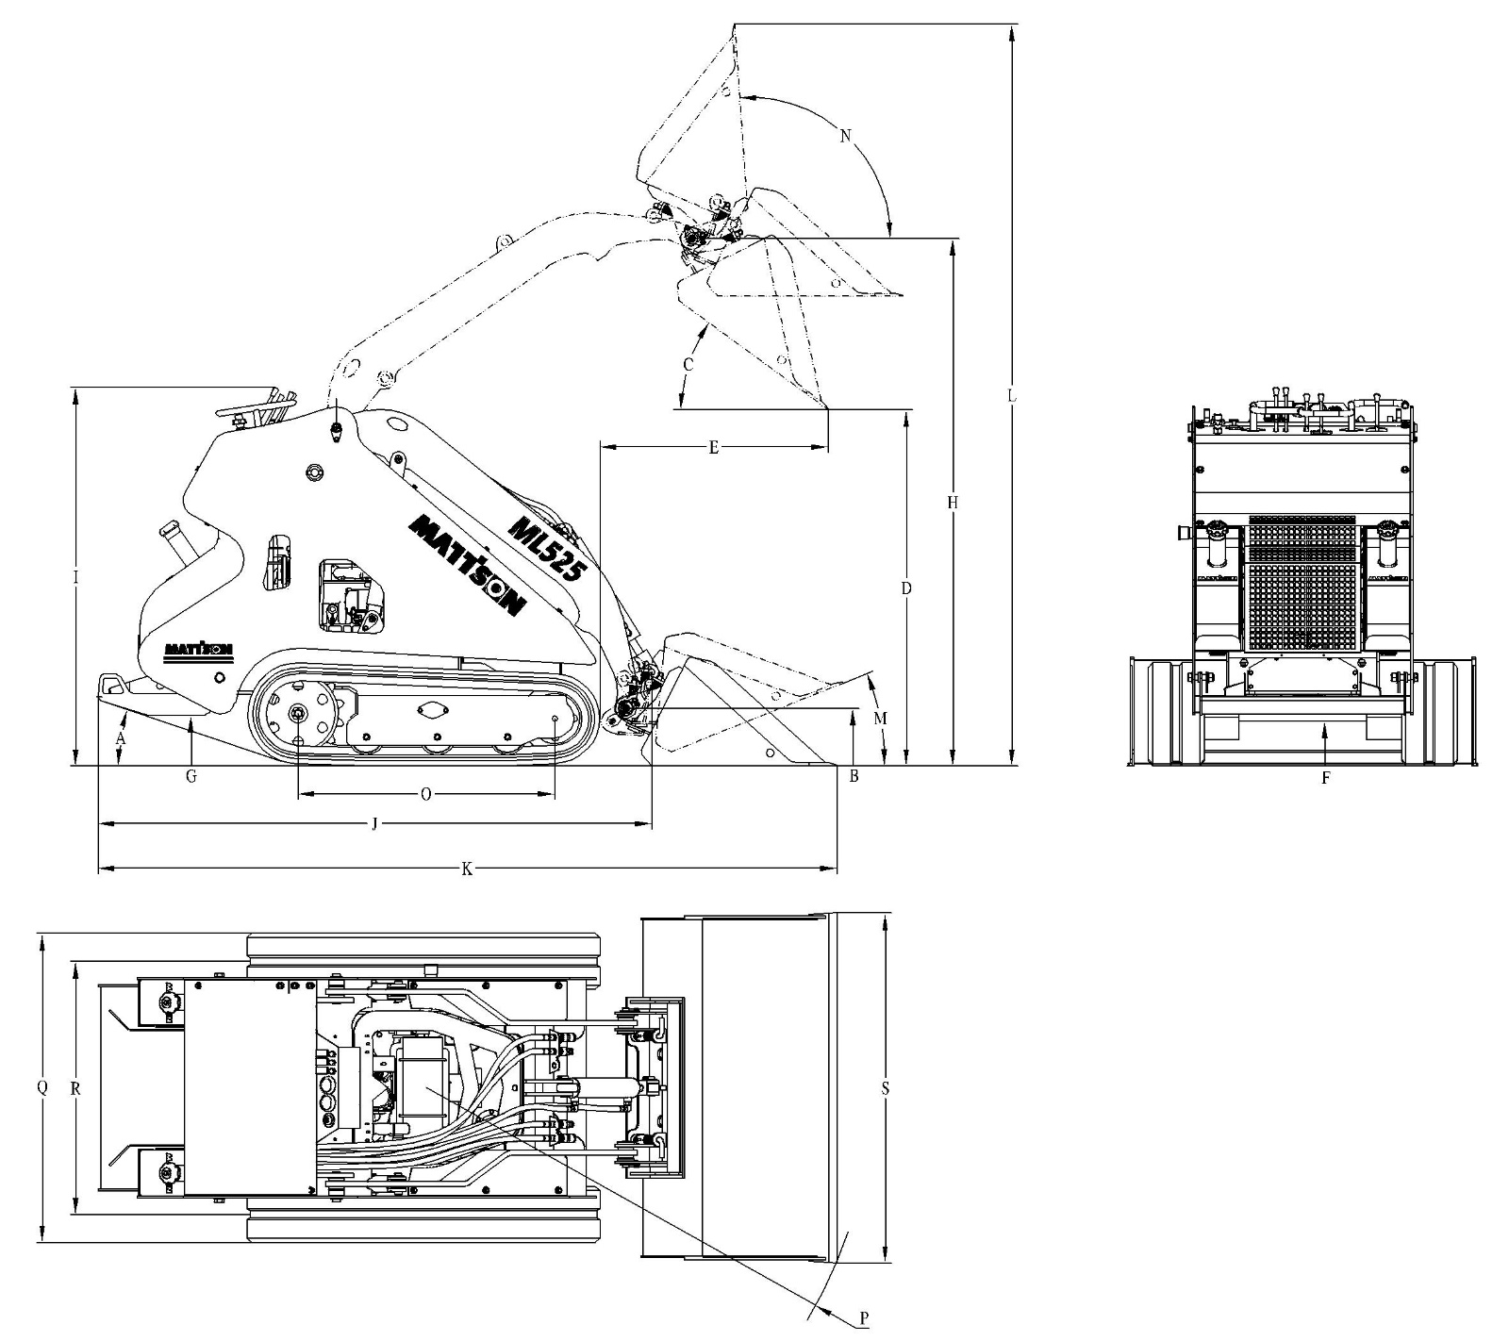

A. Angle of Departure ................................. 19°
B. Carry Position ........................................ 206 mm
C. Dump Angle @ Maximum Height ............ 36°
D. Dump Height with Standard Bucket ........ 1272 mm
E. Dump Reach @ Maximum Height ........... 815 mm
F. Ground Clearance .................................. 159 mm
G. Ground Clearance-under platform ........... 180 mm
H. Height to Bucket Hinge Pin .................... 1883 mm
I. Height ...................................................... 1352 mm
J. Length without Attachment ............................ 1976 mm
K. Length with Standard Bucket ......................... 2637 mm
L. Operating Height ....................................... 2649 mm
M. Rollback @ carry Position........................... 22°
N. Rollback Fully Raised
@ Maximum Height................................... 94°
O. Ground Contact Length ............................. 918 mm
P. Turning Radius with Standard Bucket ....... 1593 mm
Q. Width ........................................................ 1104 mm
R. Wheel Tread (over tracks) .......................... 904 mm
S. Width with 36" Bucket .................................. 1250 mm

PERFORMANCE

Operating Capacity (35%) ........................................................................................................................................ 291 kg
Operating Capacity (50%) ..................................................................................................................................416 kg
Tipping Capacity.................................................................................................................................................832 kg
Weight (no attachment) .....................................................................................................................................1060 kg
Travel Speed .................................................................................................................................................... 5.6 km/h

ENGINE/ELECTRICAL
Make/Model ................................... Kubota // D1105-E4B-CSR-1
Fuel/Cooling ................................... Diesel/Liquid Horsepower (SAE Gross) ............... 18.5kW
Maximum Governed RPM .............. 3000 RPM
Torque @ 2200 RPM (SAE Net) ..... 71.5 Nm
Number of Cylinders 3
Displacement ................................. 1.123L
Bore/Stroke .................................... 78mm/78.4 mm
Fuel Consumption .......................... 6.1 L/h
Lubrication ..................................... Gear Pump Pressure Crankcase Ventilation .................... Closed
Air Cleaner ..................................... Dry replaceable cartridge with safety element
Ignition ........................................... Diesel-Compression
Engine Coolant ............................... Propylene glycol/water mix (53%-47%)
with freeze protection to -37°C
Starting Aid .................................... Glow plugs
Alternator ....................................... Belt Driven; 40 amps; Open
Battery ........................................... 12 V；45Ah
Starter ............................................ 12 volt；Gear Reduction Type; 1.4 kW

HYDRAULIC SYSTEM
Pump Type ............................................... Engine driven, Two Gear type
Pump Capacity ........................................ 53.4L/min@ 3000 RPM
System Relief @ Quick Couplers ............. 210 Bar
Hydraulic Filter ......................................... Full flow replaceable, 10 micron synthetic media element
Hydraulic Cylinders .................................. Double-acting
Main Control Valve ................................... 5-Spool, open center series parallel configuration
Attachment Control Valve…………………. 2-Spool, open center series parallel configuration
Bore Diameter
Lift Cylinder (2) .................................. 45mm
Tilt Cylinder (1) .................................. 55mm
Rod Diameter
Lift Cylinder (2) .................................. 25 mm
Tilt Cylinder (1) .................................. 30 mm
Stroke
Lift Cylinder (2) .................................. 295 mm
Tilt Cylinder (1) .................................. 280mm
Hydraulic Function Times
Raise Lift Arms .................................. 3.5 Seconds
Lower Lift Arms .................................. 2.4 Seconds
Bucket Dump ..................................... 2.5 Seconds
Bucket Rollback ................................. 1.8 Seconds

DRIVE SYSTEM
Main Drive .............. Fully hydraulic rubber track drive
Transmission .......... Direct drive of hydraulic motor to main undercarriage drive sprocket Tracks .................... 200 mm wide
Rollers……………..5 Each side
Pressure ………….. 25.3 kPa

CAPACITIES
Cooling System ..................................... 5.2 L
Fuel Tank ................................................ 35 L
Engine Oil with Filter .............................. 5.1L
Hydraulic Reservoir ............................ …34 L
Hydraulic System ............................... ….40 L

CONTROLS
Vehicle Steering ................... Direction and speed controlled by two handle
Lift & Tilt ........................ Controlled by one hand lever
Front Auxiliary (Std.) ...... Controlled by one hand lever
Auxiliary Pressure Release .. Fore and aft movement of hand lever after engine has been shut off. Engine ................................. Hand lever throttle: Key-type starter switch and shutdown
Starting Aid .......................... Glow Plugs – Activated by key switch

INSTRUMENTATION
The mini track loader conditions are monitored by a combination of gauges and warning lights in the operator’s line of sight that monitor the following functions. The system shall alert the operator of
monitored loader malfunctions by way of an visual warning lights.

Gauges Warning Lights
Hour meter Engine Oil Pressure
Fuel Engine Coolant Temperature
System Voltage

